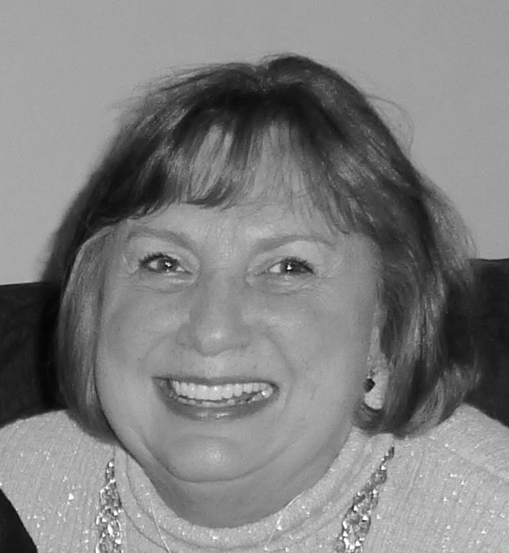
Brewer (Laird)
Kathleen Mary
Age 74, raised in West 7th area
"The beautiful blond girl on Chatsworth"

Peacefully met her Savior Nov 6, 2017 surrounded by her husband and all 10 of her children. Preceded in death by father William F. Laird and brother James G. Laird. Survived by her mother Mary E. Laird (age 102), loving husband of 55 years Frank H. Brewer, children: Joe (Salina), Dan (Rachel), Mary Beth Moline, Laura (Steve) Amelse, Tom (Kerry), James (Carrie), Mark, Frank, Amy Rose (Jimmy) Reynolds, and Teresa (Jon) Voorhies and honorary son James Regnier. Also 23 grandchildren and 3 greats. Many, including her husband, were struck by her smile. It bellied a generous heart of service to her family, and professionally as a nurse to the handicapped. Her unequivocal example of love and faith and her gracious example will forever be our guide. Visitation Mon Nov 13, 6-8pm, prayer at 7:30 @ Roberts Funeral Home IGH. Funeral Tues Nov 14 11am @ Church of St. Joseph WSP, visitation 1 hour prior, luncheon following service. In lieu of flowers please consider donations to St. Paul’s Outreach, NET Ministries, or Wakota Life Care.

