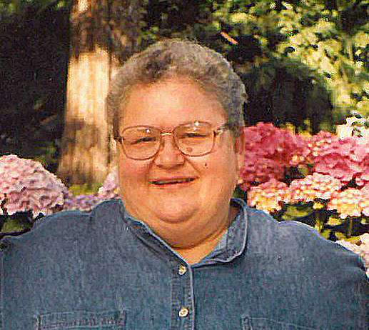
Cecilia Ann “Cookie” SMITH
Age 72, of Inver Grove Heights passed away peacefully, surrounded by family and friends on April 29, 2018. Preceded in death by parents Marion and Loretta Smith; brother Michael Smith. Survived by sister-in-law Mary Ellen Smith, close friends and many nieces, nephews, grandnieces, grandnephews, great niece and great nephew. Our Lady of Peace High School Class of 1963, St. Joseph’s Hospital Class of 1966 Practical Nurse. Cookie worked in the NICU area of Regions Hospital for over 40 years. She was a very strong and independent woman who loved to travel, bake, scrap-book, manicure her flower garden, plan events with friends and spend countless hours spoiling her dogs and cats. Her laugh was infectious and will be missed. Private burial at St. Patrick’s Cemetery in Inver Grove Heights where her ashes will be placed adjacent to her brother.

